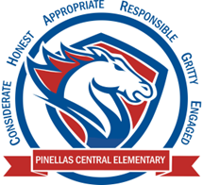

**Pinellas Central Elementary School**

**4th Grade School Supply List 2023-2024**

**Student Items (for individual student use)**

* **1 pair of headphones (necessary for 1 to 1 computers) must stay at school -please put in labeled plastic zipper bag**
* 5 folders with pockets and prongs – (plastic only)
* 4 composition notebooks
* 4 spiral notebooks
* **24 - #2 pencils (no mechanical pencils please)**
* 1 pack of glue sticks
* **4 dry erase markers**
* 1 pack wide-ruled paper

**Supplemental Classroom Items-Donations Welcome**

* 2 packs of sticky notes (varied sizes)
* 1 pack of multi-colored colored pencils
* 1 pack of multi-colored markers
* plastic zipper bags (all sizes are needed, especially gallon)
* antibacterial wipes
* tissues
* hand sanitizer
* page protectors